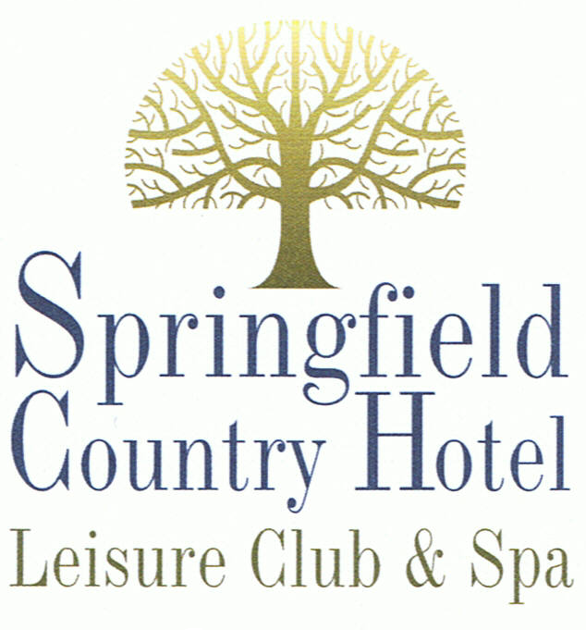

Menu

Orders Taken 7.00 – 9.00 pm

Starters

Smoked Salmon Cornets
Filled with plump Atlantic prawns in a Marie rose sauce
Fan of Chilled Seasonal Melon
Served with a refreshing sorbet on a raspberry coulis sauce
Deep Fried King Prawns
In a tempura batter with a sweet chilli sauce
Fried Breaded Mushrooms
With a salad garnish and garlic mayonnaise
Grilled Slice of Goats Cheese
Set on a crispy crouton and drizzled with balsamic glaze
Ardennes Pate
Accompanied with warm toast and a plum and apple chutney
Homemade Soup of the Day
With a roll and butter
** ** **

Main Course

All our main courses (unless specified) are served with seasonal vegetables and potatoes of the day

Prime Sirloin Steak (£2.50 Supplement) or Fillet Steak (£5.00 Supplement)
Cooked to your liking and served with a choice of either Dianne or pepper sauce or a grill garnish
Grilled Butterfly Chicken Breast
With Cajun spices served with a roast tomato chutney and dauphinoise potatoes

Braised Lamb Shank served in a Lightly Minted Jus

Slow Roast Pork Belly served in a Sticky Apricot & Herb Sauce
Sliced Sautéed Duck Breast served with an Orange Sauce & Grand Marnier Sauce
Cod Fillet in a Homemade Beer Batter
Baked Crumbed Whole Tail Scampi served with petit pois and French Fries
Poached Filet of Lemon Sole in a white wine and cream sauce

Poached Four Cheese Tortellini in a creamy tomato and basil sauce
Baked Spinach and Ricotta Cheese Cannelloni served with a small side salad
** ** **

Children’s Menu

All our children’s dishes are served with your choice of

Chips or Curly Fries
&
Peas or Baked Beans

Cod Fish Fingers
Turkey Dinosaurs
Cheese and Tomato Pizza
Ham and Pineapple Pizza
Battered Chicken Nuggets
Burger served with or without Cheese

£9.50

** ** **

Sweets

Fresh Strawberries set in either a Meringue or a Brandy Snap Basket with Chantilly Cream
Profiteroles filled with Vanilla ice cream and topped with Chocolate Sauce
Banoffee Pie with Digestive Base and Chantilly Cream
Steamed Syrup Sponge Pudding with Custard
Fresh Fruit Salad in a Stock Syrup
Honeycomb and Vanilla Cheesecake

** ** **

Fresh Coffee
Served with chocolate mints

** ** **

Two Course Dinner with Coffee at £24.50 per person and £13.00 per child aged 12 – 16 years
Three Course Dinner with Coffee at £29.50 per person and £18.00 per child aged 12 – 16 years

